Q.2. (A) The composition of the Vapor from the Flash Drum is as follows:- (Without Quenching)

**Molar flow rate of vapor is 4006.95 lbmol/hr**

With flow rate different components i.e., **for H2 is 1996.83 lbmol/hr ; For CH4 is 1976.21 lbmol/hr ; for Benzene is 31.6485 lbmol/hr ; For toluene is 2.26553 lbmol/hr**

**Then comes the compositions of the components :-   
(a) H2 (in vapor) = 0.49384  
(b) CH4(in vapor) = 0.49316  
(c) Benzene(in vapor) = 0.00789839  
(d) Toluene(in vapor) = 0.0005654**

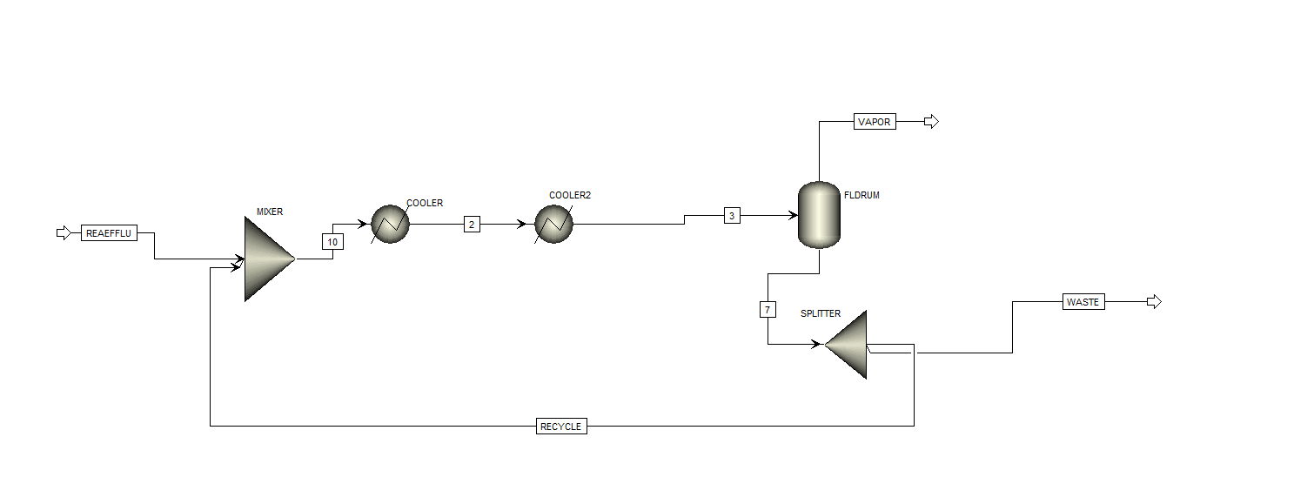

(I)

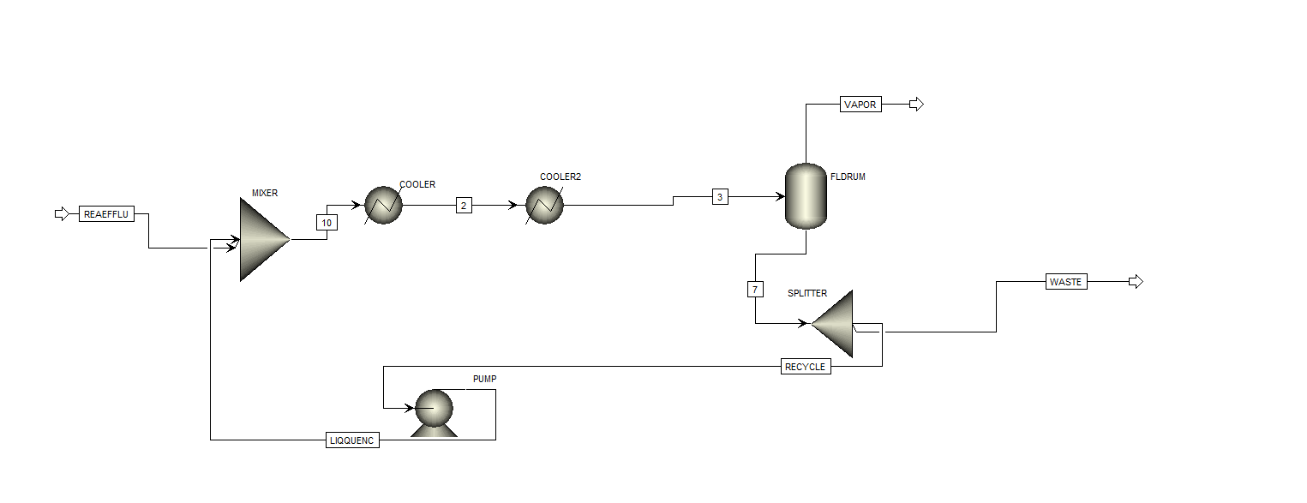

(II)

Both above flowsheets are the Quench(II) and without Quench(I)

With Quenching ,(Table)

|  |  |  |  |  |  |  |  |  |  |  |
| --- | --- | --- | --- | --- | --- | --- | --- | --- | --- | --- |
| Mole Flows | lbmol/hr | 9937.059008 | 9937.059008 | 5930.104545 | 9937.059008 | 5337.09409 | 4600 | 5337.09409 | **4006.954463** | 593.0104545 |
| H2 | lbmol/hr | 2028.546256 | 2028.546256 | 31.71942668 | 2028.546256 | 28.54748401 | 2000 | 28.54748401 | **1996.826829** | 3.171942668 |
| CH4 | lbmol/hr | 2213.937519 | 2213.937519 | 237.7239177 | 2213.937519 | 213.9515259 | 2000 | 213.9515259 | **1976.213601** | 23.77239177 |
| Benzene | lbmol/hr | 4714.998649 | 4714.998649 | 4683.350147 | 4714.998649 | 4215.015132 | 500 | 4215.015132 | **31.6485014** | 468.3350147 |
| TOLUENE | lbmol/hr | 979.5765849 | 979.5765849 | 977.3110534 | 979.5765849 | 879.579948 | 100 | 879.579948 | **2.265531492** | 97.73110534 |

(B) As it is seen that **Impact of Quench on Flash Separation**

* The quench reduces the temperature before flashing but does not significantly change the equilibrium separation at 500 psia. The vapor-to-liquid ratio remains nearly the same, confirming that **quenching affects cooling efficiency but not phase separation**.
* There is not much change in the vapor phase mole fraction and molar flow rates of the components.
* The quench stream effectively lowers the process stream temperature but has **minimal impact** on flash separation results.

Q.5. (I)

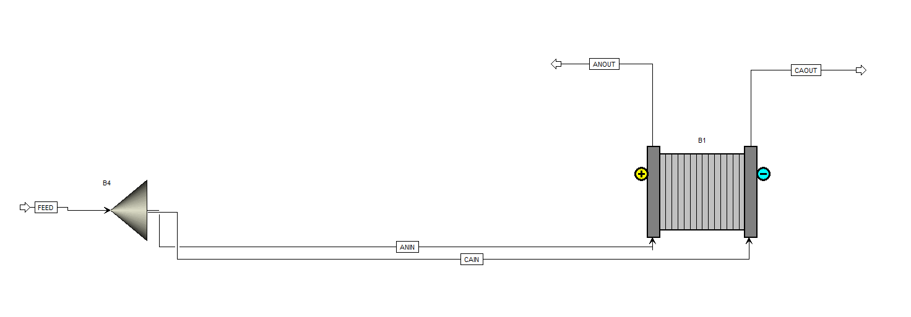

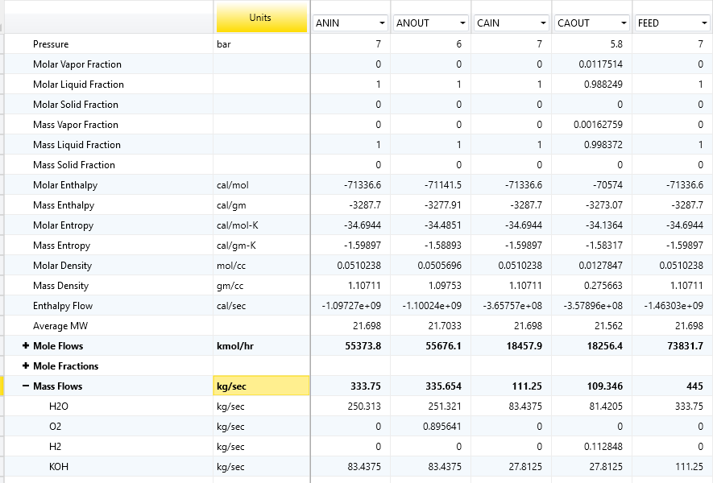

Here the Shortcut method was used.

**The Rate of production of H2 is 0.112 kg/sec and The rate of production of O2 is 0.895 kg/sec.  
Here** the Water that is going to Anode and Cathode is about 333.75 kg/sec**, in which** the In anode the water inlet is 250.313 kg/sec **and** Cathode inlet is 83.4375 kg/sec **, so at the end** the outlet of water at anode is 251.321 kg/sec and Cathode outlet for water is 81.4205 kg/sec.

From the data:

* FEED (Total Inlet): 333.75 kg/sec (H2O)
* ANOUT (Outlet): 251.321 kg/sec (H2O)
* CAOUT (Outlet): 81.4205 kg/sec (H2O)

The total water leaving the system is the sum of the water in the ANOUT and CAOUT streams:

Total Outlet Water = ANOUT (H2O) + CAOUT (H2O) = 251.321 kg/sec + 81.4205 kg/sec = 332.7415 kg/sec

The rate of water consumption is the difference between the total inlet water and the total outlet water:

Water Consumption = FEED (H2O) - Total Outlet Water = 333.75 kg/sec - 332.7415 kg/sec = 1.0085 kg/sec

**So, the rate of water consumption is approximately 1.0085 kg/sec.**

From the table:

* ANIN (Inlet): 250.313 kg/sec
* ANOUT (Outlet): 251.321 kg/sec

The makeup water required would be the difference between the outlet and inlet water flow rates:

Makeup Water = ANOUT (H2O) - ANIN (H2O) = 251.321 kg/sec - 250.313 kg/sec = 1.008 kg/sec

**So, the makeup water required is approximately 1.008 kg/sec.**

ii) 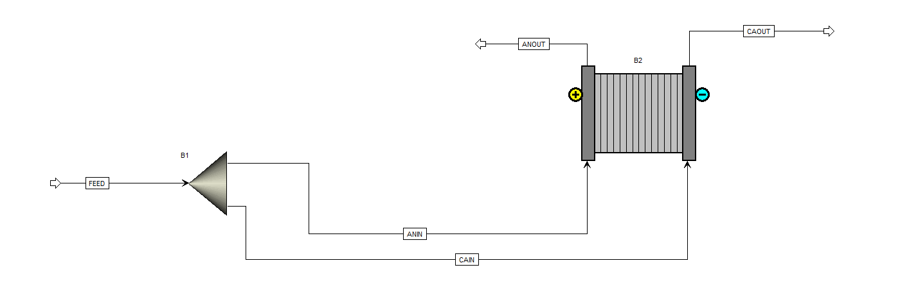

Rigorous Method

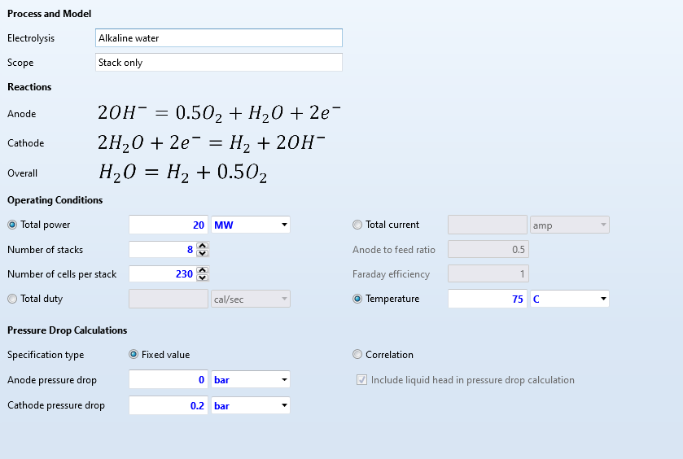

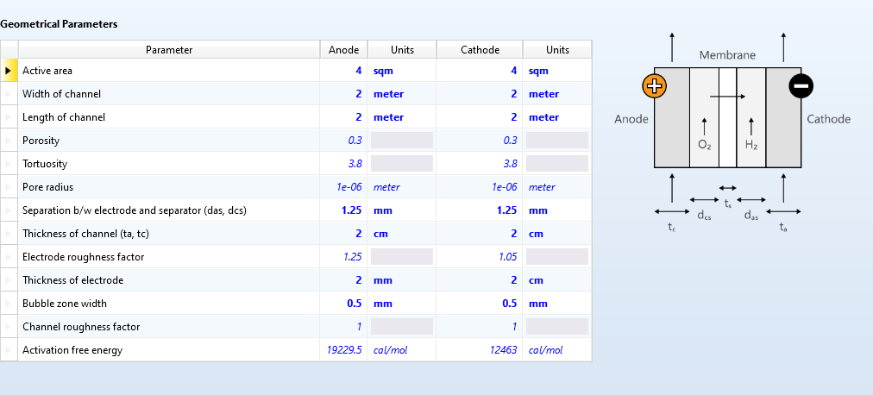

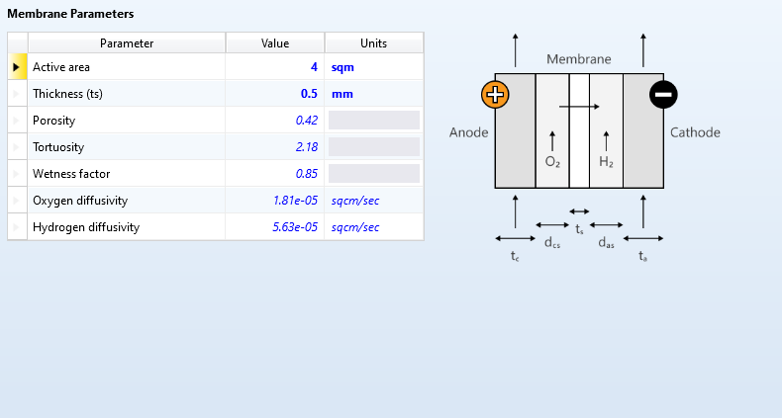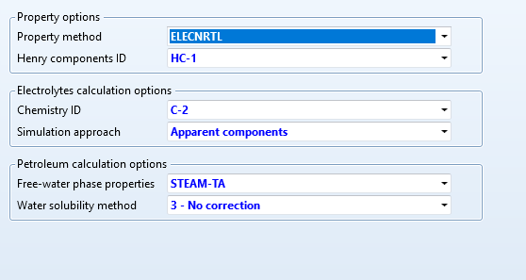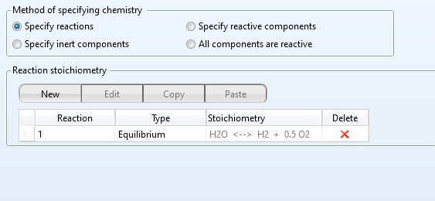Reaction Components

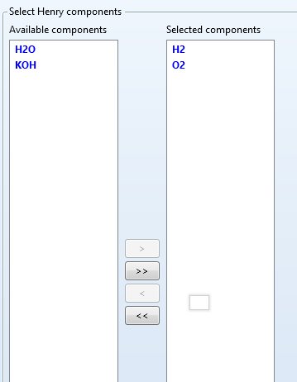Henry Components

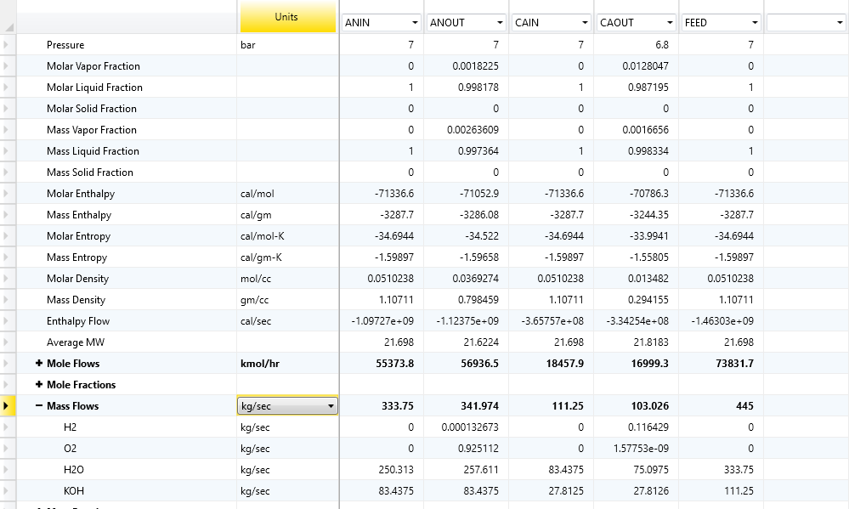

**a. Electrolyzer Efficiency**

The efficiency of an electrolyzer can be calculated using the formula:

Efficiency=[(Energy content of hydrogen produced)/(Electrical energy input)]×100%

The energy content of hydrogen is typically given by its lower heating value (LHV), which is approximately 33.33 kWh/kg.

From the provided data:

* Total power input = 20 MW
* Number of stacks = 8
* Number of cells per stack = 230

First, calculate the total electrical energy input per second:

Electrical energy input=20 MW=20×106 W=20×106 J/s

Next, determine the mass flow rate of hydrogen produced. From the table, the mass flow rate of H₂ at the cathode is 0.116429 kg/s.

Now, calculate the energy content of the hydrogen produced per second:

Energy content of hydrogen=0.116429 kg/s×33.33 kWh/kg×3600 s/h  
Energy content of hydrogen≈13999.8 kJ/s  
Now, calculate the efficiency:

Efficiency = [(13999.8 /20×103)] ×100%≈70%

**b. Energy Requirements per Unit Mass of H₂ Production**

The energy requirement per unit mass of hydrogen production can be calculated as:

Energy requirement = Electrical energy input/Mass flow rate of hydrogen

Using the values from above:

Energy requirement=20×106 /0.116429≈171.8 MJ/kg

This value can also be expressed in kWh/kg:

Energy requirement=171.8/3.6≈47.7 kWh/kg

(III) Flowsheet as follows:-

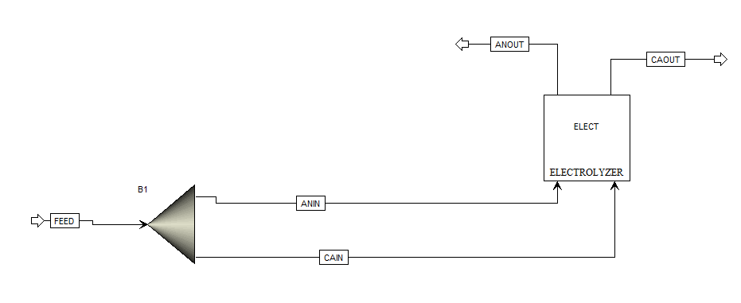

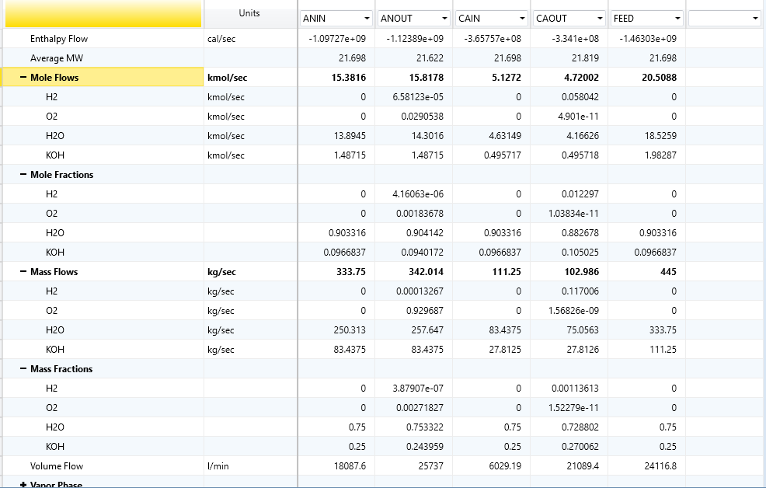

The molar mass of H₂ is approximately 2 g/mol or 0.002 kg/mol.

Molar flow rate of H2 = 0.117006/0.002 = 58.503 mol/s

Since the purity of H₂ is 96%, the actual molar flow rate of H₂ produced is:   
Actual Mass flow rate of H2 = 58.503/0.96 = 60.94 mol/s

According to the stoichiometry of the reaction, 1 mole of water is required to produce 1 mole of H₂.

So, Molar flow rate of H2O=60.94 mol/s

The molar mass of water (H₂O) is approximately 18 g/mol or 0.018 kg/mol.

Mass Flow rate of H2O = 60.94 × 0.018 = 1.096 kg/s

1.

**For separation of the C2/C3 (direct separation)**

* **Flowsheet for Direct Sequence (C2/C3 separation first)**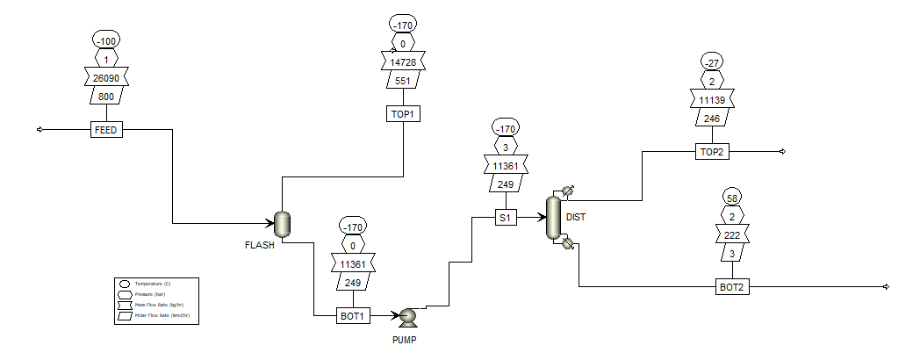

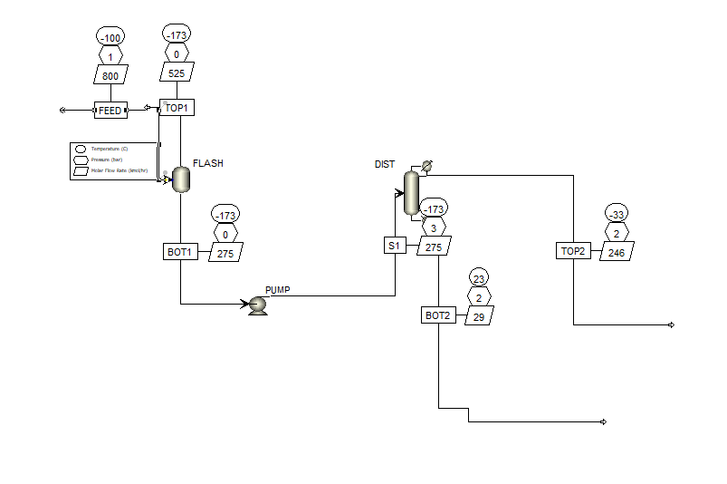

By Binary analysis plot of C2/C3 we get a range of flash temperature to operate

Temperature range for flash = -40 to -47.5 °C



**For separation of the C3/C4 (Indirect separation)**

* **Binary Analysis of C3/C4**



* By Binary analysis plot of C3/C4 we get a range of flash temperature to operate

Temperature range for flash = -2.5 to -5.0 °C